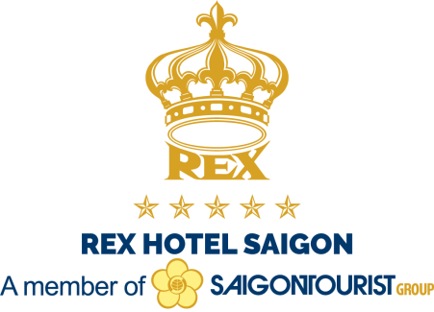

**REX Hotel Saigon**

141 Nguyen Hue Street, District 1, Ho Chi Minh City, Vietnam

Trần Quốc Anh (**Mr ANH**)

Sales Manager

**Mobile: (+84) 886 828 685** (available on WhatsApp / Viber / Zalo / Telegram)

**Email: tq.anh@rex.com.vn / quocanh24111991@gmail.com**

**Tôn Đức Thắng University Guests Reservation Form**

**(only for guests attending Tôn Đức Thắng University in December 2024)**

*Greetings from the REX Hotel Saigon,*

*Kindly please fill-out your reservation detail as follows;*

. Family Name: ……………………………………

. First Name: ……………………………………

. Address: ………………………………………………………………

………………………………………………………………

. Mobile Phone: ……………………………………

. Email: ……………………………………

. Check in date: ……………….. Arrival Time: ………………… Flight no: ……………..

Airports pick up request: Yes……… No………

. Check out date: ……………….. Departure Time: ……………… Flight no: ……………..

Airports drop off request: Yes……… No………

. Estimated number of nights: ….……….

. Estimated number of rooms: ….……….

. Room type: ………………………….

. Single (01 guest/room)…..……… Double (02 guests/room, 01 double bed)………...

. Twin (02 guests/room, 02 single beds separately)…………

. Triple (03 guests/room, Double + extra bed, or Twin + extra bed)………….

Pick up / Drop off service (between airport and the hotel)

. 04 seat car (Day time - From 06.00 to 21.00): US$ 50 nett/way/ 1-2 people/car

. 07 seat car (Day time - From 06.00 to 21.00): US$ 50 nett/way/ 1-3 people/car

. 15 seat van (Day time - From 06.00 to 21.00): US$ 60 nett/way/ 4-10 people/vehicle

. 04 or 07 seat car (Night time - From 21.05 to 05.55): US$ 60 nett/way/car

. 15 seat van (Night time - From 21.05 to 05.55): US$ 70 nett/way/van

*. The “nett” room rate is “all-in” rate, including 05% service charge and prevailing government tax*

*. Total room charges are calculated by the total number of night stayed, day-use room is equivalent to 01 night stay*

|  |  |  |
| --- | --- | --- |
| **ROOMs and SUITEs** | **CORPORATE ROOM RATES 2024**  **Only for Tôn Đức Thắng University**  **(Applied from December 01st until December 26th 2024)** | |
| **at EAST Wing** & **WEST Wing** | **Single**  (01 guest/room) | **Double or Twin**  (02 guests/room) |
| **Deluxe** *(25 to 27 m2) - East* | *(Rack rate: USD 204.12)*  ***2.600.000 VND Nett*** | *(Rack rate: USD 249.48)*  ***3.200.000 VND Nett*** |
| **Premium** *(38 m2) - West*  *(top choice)* | *(Rack rate: USD 238.14)*  ***2.900.000 VND Nett***  *(limited offer)* | *(Rack rate: USD 283.50)*  ***3.400.000 VND Nett***  *(limited offer)* |
| **REX Suite** *(40-45 m2) - East* | *(Rack rate: USD 272.16)*  ***3.400.000 VND Nett*** | *(Rack rate: USD 317.52)*  ***3.900.000 VND Nett*** |
| **Governor Suite** *(55 m2) - West*  *(top choice)* | *(Rack rate: USD 317.52)*  ***3.900.000 VND Nett*** | *(Rack rate: USD 362.88)*  ***4.400.000 VND Nett***  *(only Double)* |
| **Premium Connecting rooms**  *(38 m2 x 2 rooms) - West (top choice)*  *(01 double king bed + 01 twin beds)* | ***7.800.000 VND Nett*** | |

*\*\*\* Double means 01 room for 02 persons (01 King-bed)*

*\*\*\* Twin means 01 room for 02 persons (02 single beds separately)*

*. The “nett” room rate is “all-in” rate, including 05% service charge and prevailing government tax*

|  |  |  |
| --- | --- | --- |
| **ROOMs and SUITEs** | **CORPORATE ROOM RATES 2024**  **Only for Tôn Đức Thắng University**  **(Applied from December 01st until December 26th 2024)** | |
| **at EXECUTIVE Wing** | **Single**  (01 guest/room) | **Double or Twin**  (02 guests/room) |
| **Executive Premium\*** *(38 m2)*  *(top choice)* | *(Rack rate: USD 294.84)*  ***3.700.000 VND Nett*** | *(Rack rate: USD 340.20)*  ***4.200.000 VND Nett*** |
| **Executive Governor Suite\*** *(57 m2)* | *(Rack rate: USD 340.20)*  ***4.700.000 VND Nett*** | *(Rack rate: USD 385.56)*  ***5.200.000 VND Nett***  *(only Double)* |
| **Executive Suite \*** *(75 m2)*  *(signature room)* | *(Rack rate: USD 544.32)*  ***8.800.000 VND Nett***  *(only Double)* | |

*\*\*\* Double means 01 room for 02 persons (01 King-bed)*

*\*\*\* Twin means 01 room for 02 persons (02 single beds separately)*

*. The “nett” room rate is “all-in” rate, including 05% service charge and prevailing government tax*

**ROOM BENEFITS:**

. Daily international buffet breakfast at Hoa Mai restaurant on the 05th floor

. In-room welcome fruits

. In-room complimentary minibar (one time only, extra charge if refill)

. 02 outdoor swimming pools

. Fitness center including Gym & sauna/steam bath

. Internet WiFi access

. In-room instant tea/coffee mini bag & bottle of water

. Free of charge for 01 child under 12 years old (must sharing bed with parent, including breakfast)

**HOTEL INFORMATION**

. Check-in time is 14:00pm, and Check-out time is 12:00 (noon)

. Early check in is subject to availability, unless the room is pre-registered for the night before.

. Late check out is subject to availability, with an additional charge of:

50% of the room rate up to 18:00pm on departure date

100% of the room rate after 18:00pm on departure date

. Due to local authority regulations, only registered guests are allowed on the guest floors. Please contact reception for more details.

**GUARANTEE POLICY**

. Credit card information is required for all the confirmed reservation at the time of the booking, which is for the booking guarantee purpose only. No payment has been charged yet. The payment of the accommodation will be totally charged upon your check -in

. Without Credit card information, please be advised that your reservation is not guaranteed for arrival after 18:00pm local time on your arrival date. The hotel reserves the right to release the room for sale after 18:00pm local time on your arrival date. Should you wish to guarantee for late arrival, please provide details of your valid Credit card.

**CANCEL POLICY:** 03 days prior to arrival to avoid One Night Fee per room

(Cancel at least 03 days before arrival. Otherwise, penalty charge 01 night per cancelled room)

**Payment**

*. If by guest’s personal account: payment / deposit by Cash or Credit / Debit card at check in (Visa, Master, JCB, American Express and Diners Club), and settle all bills before departure.*

For a better arrangement, the form should be sent to the REX Hotel at least one month before arrival date as well as you must have a booking confirmation from us.

Thank you for your support to the REX Hotel Saigon,

**Kindly please send the form to (Mr Anh)** - Email: **tq.anh@rex.com.vn**

**quocanh24111991@gmail.com**

Mobile: (+84) 886 828 685 (available on WhatsApp / Viber / Zalo / Telegram)



Thank you for considering the REX Hotel Saigon for your upcoming event. We are glad to connect you with whatever you require for a comfortable stay.

Our venue is located in the heart of Ho Chi Minh City, just a few steps away from renowned shopping malls, fancy restaurants, and nightlife attractions. The REX Hotel Saigon is an ideal place for conducting business meeting, banquet, and wedding in style. Our 286 spacious hotel rooms and suites are designed to deliver memorable experience with personalized service and convenient amenities. Explore a wonderful retreat in our 74 Executive rooms at Executive Wing, or simply unwind in one of the newly renovated rooms at West Wing, or experience ancient architecture in the room at East Wing.

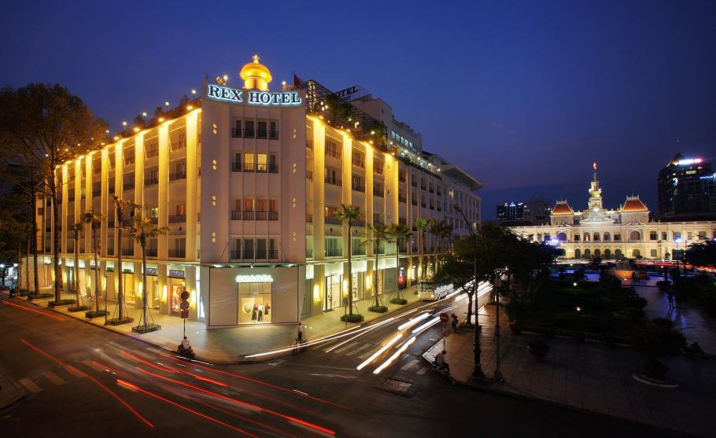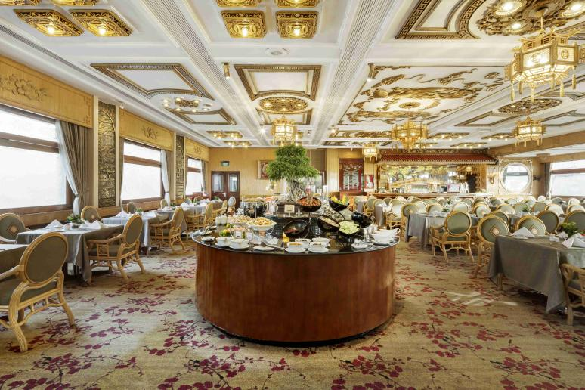

|  |
| --- |
| **For Your Dining or Entertaining Pleasure** |

. **Rooftop Garden restaurant & bar** on the 05th floor: one of “1000 places to see before you die”, overlooking a great city vista, breathtaking view at sunset, the iconic restaurant & bar has its past famous calling “Five O’clock Follies” in the 60s.

. **Paradise coffee lounge** at the Ground floor: a fancy lounge features live piano daily in the afternoon, and evening. The ideal business meeting spot with unique architecture

. **Vertical Garden** at the Ground floor: the biggest in-door gravity-defying garden is perfect for breakfast, or sipping cocktail and chilling in the afternoon

. **Hoa Mai restaurant, and Hoang Sa restaurant**: 02 unique traditional design restaurants, offering exquisite dining, especially European and Vietnamese cuisines

. **REX Havana Cigar Club**: the first & the unique Cigar club lounge in Vietnam, offering all type of authentic, original & famous villa zamorano cigars from Cuba. Come and experience fresh rolled cigars, as well as indulge yourself in this exotic lounge with drinks.

. **REX Hotel’s pool bar** on the 5th floor.